When training generative adversarial networks (GAN) with insufficient data, discriminator overfitting frequently happens, causing training to diverge. Adaptive discriminator augmentation technique greatly stabilizes training under low-data conditions. On numerous datasets, it shows that good results can now be achieved with only a small number of training photos, frequently matching StyleGAN2 results with orders of magnitude less images.
Training an image classifier under rotation, noise, etc., leads to increasing invariance to these semantics-preserving distortions — a highly desirable quality in a classifier. In contrast, a GAN trained with comparable dataset augmentations learns to produce the augmented distribution. Such "leaking" of augmentations to the created samples is generally very unwanted. For instance, a noise augmentation produces noisy results even when there is no noise in the dataset.
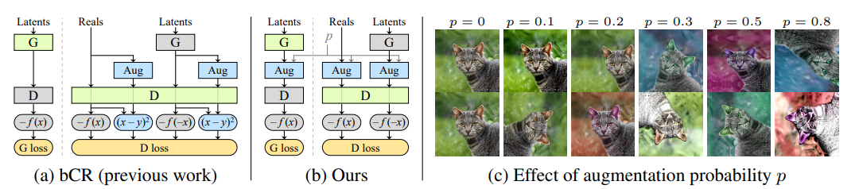
The solution is similar to balanced consistency regularization (bCR) in that applying a set of augmentations to all images shown to the discriminator. However, instead of adding separate CR loss terms, the discriminator is evaluated only using augmented images, and do this also when training the generator.
Ideally, StyleGAN2-ADA avoids manual tuning of the augmentation strength and instead controls it dynamically based on the degree of overfitting. The discriminator outputs by Dtrain, Dvalidation, and Dgenerated for the training set, validation set, and generated images, respectively, and their mean over N consecutive minibatches are denoted by E[·]. In practice, N = 4 is applied, which corresponds to 4 × 64 = 256 images.
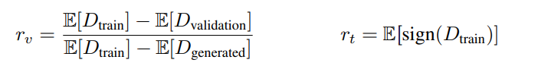
For both heuristics, r = 0 means no overfitting and r = 1 indicates complete overfitting, and the goal is to adjust the augmentation probability p so that the chosen heuristic matches a suitable target value.Augmentation strength p is controlled as follows. p is initialized to zero and adjusted once every four minibatche, based on the chosen overfitting heuristic. If the heuristic indicates toomuch/little overfitting, p is incremented/decremented by a fixed amount. Adjustment size is set in a way so that p can rise from 0 to 1 sufficiently quickly, e.g., in 500k images. After every step p is clamped from below to 0. this variant is called adaptive discriminator augmentation (ADA).
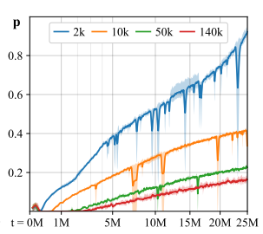
With a 2k training set, augmentations were applied almost always towards the end.
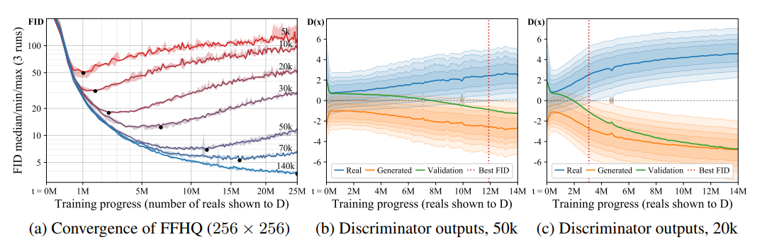
Figure 1
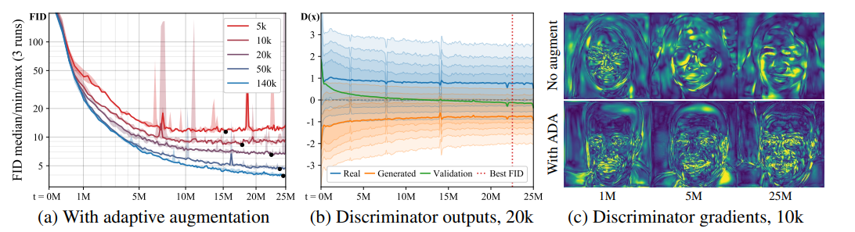
Figure 6: (a) Training curves for FFHQ with different training set sizes using adaptive augmentation. (b) The supports of real and generated images continue to overlap. (c) Example magnitudes of the gradients the generator receives from the discriminator as the training progresses.
Figure 6 repeats the setup from Figure 1 using ADA. Convergence is now achieved regardless of the training set size and overfitting no longer occurs.

